Static Equilibrium

**Equipment**

|  |  |  |
| --- | --- | --- |
| Qty | Part # | Description |
| 1 | ME-7034 | Meter Stick Pivot |
| 1 | ME-7035 | Torque Mass Hanger |
| 1 |  | Meter Stick, Aluminum |
| 1 | ME-8738 | 90 cm Stainless Steel Rod |
| 1 | ME-8988 | 25 cm Stainless Steel Rod |
| 1 | ME-9472 | Large Table Clamp |
| 1 | ME-9507 | Multi-Clamp |
| 1 | PS-3202 | Wireless Force Acceleration Sensor |
| 1 | SE-8759 | Hooked Mass Set |

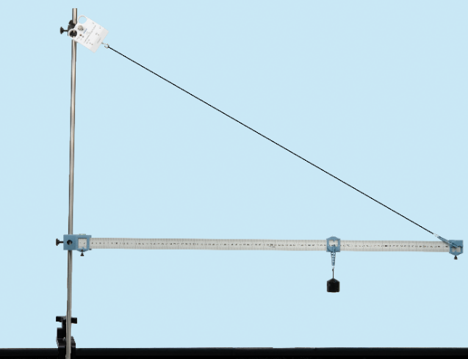

*Figure 1: Horizontal Meter Stick in Equilibrium*

**Introduction**

There are two requirements for an object to be in static equilibrium:

1. The sum of the torques is zero.
2. The sum of the forces is zero.

An object is hung from a horizontal meter stick which is suspended from a vertical rod by a string. Summing the torques, the equation is solved for the tension in the string. The tension in the string is also measured directly with the Wireless Force Sensor.

By summing the forces, the force at the pivot is determined.

**Theory**

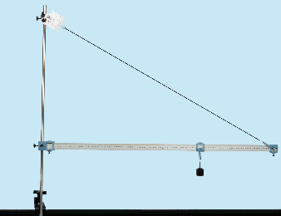

Pivot

1 cm

Make a freebody diagram for the meter stick shown above. Draw the force vectors and the distances from the pivot point at the 1 cm mark. Fx and Fy are the horizontal and vertical forces of the pivot on the meter stick. The weight of the meter stick is mg and it acts at the center of mass of the meter stick. F1 is the weight of the hanging mass and FT is the tension in the string.

The requirements for equilibrium are that the sum of the torques about the pivot is zero, the sum of the horizontal forces is zero, and the sum of the vertical forces is zero.

${Σ\vec{τ}}_{pivot}=0$ (1)

$Σ\vec{F_{x}}=0$ (2)

$Σ\vec{F_{y}}=0$ (3)

$τ=rFsinθ$ (4)

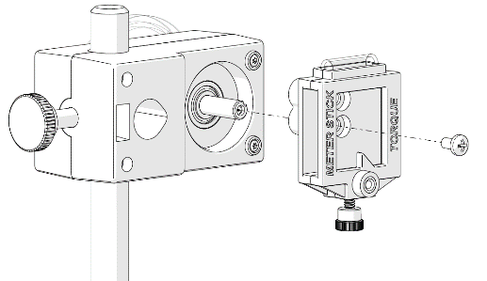**Setup**

1. Using a scale, find the mass of the meter stick.
2. Check that the meter stick clamp is screwed to the meter stick pivot through the center hole of the meter stick clamp as shown at right.
3. Using the table clamp, clamp the 90-cm rod to the table. Then slide the meter stick pivot onto the rod.
4. Near the top of the rod, connect a cross-rod with the multi-clamp and 25-cm rod. Slide the Wireless Force Sensor onto the cross-rod. Leave the set screw loose on the Force Sensor so the Force Sensor can easily rotate on the rod.
5. Slide the zero end of the meter stick into the meter stick clamp on the pivot. Clamp the stick at the 1-cm mark. Then slide a mass hanger onto the meter stick and clamp it at the 60-cm mark.
6. Slide a mass hanger with the hook side up onto the end of the meter stick and clamp it at the 99-cm mark. Tie a string from the hook to the Force Sensor hook so the meter stick is approximately level. Hang a 200-g mass from the mass hanger at the 60-cm mark. Make sure the force sensor is aligned with the string and tighten the set screw on the force sensor.
7. Make the final adjustment to make the meter stick level by sliding the pivot up or down on the rod until the bubble level on the pivot shows it is level. Then secure the pivot to the rod with the set screw.

**Procedure**

1. Turn on the Wireless Force Sensor and connect it in Capstone. Lift up on the string so there is no force on the force sensor. In Capstone, zero the force sensor. Then let go of the string and make sure the force sensor is aligned with the string.
2. Record the force.
3. To determine the angle between the string and the meter stick, use a protractor or measure the rise over run.

**Analysis**

1. Using equation (1), solve for the string tension and determine the theoretical value of the tension. (Reminder: The mass hanger adds 10 g). Compare this to the measured value of the tension.
2. Using equations (2) and (3), solve for the x- and y-components of the force of the pivot on the meter stick.
3. Using the x- and y-components of the force, calculate the magnitude and angle of the force of the pivot on the meter stick.
4. Because every point in the meter stick is in equilibrium, the sum of the torques about any point is zero. Prove this for the point (99 cm) at which the string is attached. Draw a freebody diagram for the meterstick with the distances measured from the 99-cm mark.

99 cm

Pivot

